

Nekta Management System





BY LEVI NJOROGE JUNIOR

**Developed by:**

**LEVI NJOROGE JUNIOR**

**Index no:**

**28512102031**

**School:**

**KERICHO DAY SECONDARY SCHOOL**

**Year:**

**2022**

**Submitted to:**

**THE KENYA NATIONAL EXAMINATIONS COUNCIL (KNEC)**

## DECLARATION

I Levi Njoroge Junior, declare that this is the true original report of my computer studies project that I carried out on my own without any external aid other than the guidance of my teacher as the supervisor of the project.

**Student:**

Name: Levi Njoroge Jr.

Index: 28512102031

Signature: ………………………

Date: ………………………

**Teacher:**

Name: Mr. Peter Kamau

Signature: …………………………

## DEDICATION

I dedicate this project to my computer studies teacher who has imparted me with the skills and knowledge to carry out this project.

Special dedication to my family who have motivated me throughout my studies and encouraged me to push forward.

## ACKNOWLEDGEMENT

I thank Jehovah God for giving me life and enabling me to complete this project.

I appreciate my loving mother who has wholesomely supported and encouraged me during the entire development process of this system. She has been my major source of motivation.

I would also like to express my deep gratitude to my computer studies teacher, Mr. Peter Kamau, for his patient guidance, enthusiastic encouragement and useful critiques of this project. I also thank him for his advice and assistance in keeping my progress on schedule.

Finally, I recognise the input by my classmates and friends who have readily provided feedback and comments that led to the improvement of this system.

Table of Contents

DECLARATION i

DEDICATION ii

ACKNOWLEDGEMENT iii

INTRODUCTION 1

Chapter 1: SYSTEM ANALYSIS 2

Problem Definition 2

Preliminary Investigation. 2

Overview of the existing system 2

Overview of the proposed system. 3

Main Objective. 4

System Objectives. 4

Benefits of Proposed System 4

Limitations of the proposed system. 5

Project scope. 5

Feasibility report 6

Development team resolutions 9

Information Gathering 9

1. Interview. 10

2. Questionnaires 11

3. Observation 12

Requirement Specifications 12

Chapter 2: SYSTEM DESIGN 14

1. System Flowchart 14

2. Table Design 16

3. Input design 18

a) Farmer’s Registration Form Design 18

b) Orders Form Design 19

c) Purchase Form Design 20

d) Transport Form Design 21

e) Trainee Registration Form Design 22

4. Output Design 23

a) Farmers Report Design 23

b) Sales Report Design 23

c) Purchase Report Design 24

d) Transport Report Design 24

e) Trainee Report Design 25

Chapter 3: SYSTEM CONSTRUCTION 26

1. Database tables 26

a. Farmers Table 26

b. Package Table 27

c. Products and Services Table 27

d. Purchase Table 27

e. Sales Table 28

f. Trainee Table 28

g. Transport Table 29

2. Database relationship diagram 29

3. Database Input Forms 30

I. Farmer’s Registration Form 30

II. Sales/Orders Form 31

IV. Transport Form 33

V. Trainee Registration Form 34

VI. Main Switchboard 35

4. Database Queries 36

I. Sales Query 36

II. Purchase Query 37

III. Transport Query 37

IV. Training Income Query 38

5. Generating Reports 39

I. Farmers Report 39

II. Sales Report 40

III. Purchase Report 41

IV. Transport Reports 42

V. Training Report 43

VI. Summarised Report 44

6. Enforcing System Security 45

Chapter 4: SYSTEM IMPLEMENTATION 46

Chapter 5: USER MANUAL 47

1. Installation Guide 47

2. Loading the system 48

3. Data entry procedure 50

4. Navigation Guide 51

5. Output Generation 53

6. Closing NektaMS 54

7. Troubleshooting guide 54

Chapter 6: CONCLUSION 55

Chapter 7: RECOMMENDATION 56

Chapter 8: BIBLIOGRAPHY 57

**Table of Figures**

Figure 1.1: Operational feasibility 7

Figure 1.2: Questionnaire 11

Figure 2.1: System Flowchart 15

Figure 2.2: Farmer’s Registration Form Design 18

Figure 2.3: Orders Form Design 19

Figure 2.4: Purchase form design 20

Figure 2.5: Transport Form Design 21

Figure 2.6: Trainee Registration Form design 22

Figure 2.7: Farmers Report Design 23

Figure 2.8: Sales Report design 23

Figure 2.9: Purchase Report Design 24

Figure 2.10: Transport Report Design 24

Figure 2.11: Trainee Table Design 25

Figure 3.1: Farmers Table 26

Figure 3.2: Package Table 27

Figure 3.3: Products and Services Table 27

Figure 3.4: Purchase Table 27

Figure 3.5: Sales Table 28

Figure 3.6: Trainee Table 28

Figure 3.7: Transport Table 29

Figure 3.8: Tables Relationship 29

Figure 3.9: Farmer’s Registration Form 30

Figure 3.10: Sales Form 31

Figure 3.11: Purchase Form 32

Figure 3.12: Transport Form 33

Figure 3.13: Trainee Registration Form 34

Figure 3.14: Main Switchboard 35

Figure 3.15: Macro for opening Farmers Registration Form 35

Figure 3.16: Sales Query 36

Figure 3.17: Purchase Query 37

Figure 3.18: Transport Query 37

Figure 3.19: Trainee Income Query 38

Figure 3.20: Farmers Report 39

Figure 3.21: Sales Report 40

Figure 3.22: Purchase Report 41

Figure 3.23: Transport Report 42

Figure 3.24: Trainee Report 43

Figure 3.25: Summarised Report 44

Figure 5.1: Splash screen 48

Figure 5.2: Login Form 49

Figure 5.3: Forms Menu group 50

Figure 5.4: Navigation Guide 1 51

Figure 5.5: Navigation Guide 2 51

Figure 5.6: Navigation Guide 3 52

Figure 5.7: Navigation Guide 4 52

Figure 5.8: Reports Menu Group 53

## INTRODUCTION

Nekta is a company that deals with beekeeping and selling of honey.

The company offers services like; selling of beehives and associates accessories to bee farmers, setting up of the beehives for the bee farmers, offering of training on beekeeping, and buying of honey and honey related products from farmers for further processing and sale to consumers.

# SYSTEM ANALYSIS

## Problem Definition

Nekta is a company that deals with beekeeping and selling of honey. Currently, the company uses manual files to maintain records. The growing sales has resulted into inefficiency and poor work environment leading to disappointment and dissatisfaction within the company. The company, therefore, needs to develop a computerised information management system that would support its daily operations.

## Preliminary Investigation.

By making a preliminary investigation, our system development team discovered some problems with the current manual system.

### Overview of the existing system

1. Increased number of customers and sales has overloaded the current system’s ability to process sales and orders
2. Delays and errors in preparing important reports has made the company to run into losses.
3. In the last three years, unpaid purchases orders have increased from 5% to over 20%. This has brought up frustrations and farmers have started losing trust in the company.
4. Poor customer services support which leads to loss of business to competitors in the beekeeping industry.
5. The farmers are to constantly fill their details whenever they needed to make purchases. This may be tedious.
6. The payment details have to be verified manually before the services are approved and offered which may be time-consuming.

### Overview of the proposed system.

It is recommended that an automated transaction processing system that would capture and process product sales and orders be used.

The system should have the following features:

1. Maintain records of;
   1. bee farmers.
   2. trainee farmers.
   3. services rendered and products sold by the company.
2. Capture the following;
   1. Payment for services to farmers.
   2. Payments made to farmers for honey deliveries.
   3. Totals sales to clients.
   4. Transport earnings.
   5. Income from training.
   6. Total income for the company.
3. Be able to present the above information in reports.

### Main Objective.

The goal of developing an automated information system for Nekta company is to improve sales processing in order to maximise profitability.

### System Objectives.

The proposed system should be able to:

* Allow the front office staff to easily enter information.
* Allow managers to maintain records of clients and transactions.
* Allow managers to process income from sales and training services.

### Benefits of Proposed System

The proposed system should be beneficial in the following ways:

1. Process sales and orders faster.
2. Reduce cases of farmers going unpaid.
3. Prepare important reports fast and efficiently.
4. Maintain records of farmers. Thus, farmers don’t need to constantly fill their details each time they transact.
5. The system automatically detects when the payments are made for the products and services thus this reduces the time it took initially for the payments details to be manually verified.
6. Allow users to search for farmers’ details and thus reducing redundancy and saving time which improves the morale of the users.

### Limitations of the proposed system.

The new automated system has a high initial cost meaning that its development is relatively expensive.

### Project scope.

Support centralised processing of business transactions relating to sales and customer orders in the company

### Feasibility report

Our development team conducted a feasibility study which mainly involved review of the current organisational data, observation and informal discussion with a few employees and customers.

The feasibility report below was compiled:

1. Schedule feasibility

This indicates that the team would take seven months to develop the proposed system.

The following schedule was drawn up:

|  |  |  |  |  |  |  |  |
| --- | --- | --- | --- | --- | --- | --- | --- |
|  | Apr | May | Jun | Jul | Aug | Sep | Oct |
| Data Collection |  |  |  |  |  |  |  |
| System Analysis |  |  |  |  |  |  |  |
| System Design |  |  |  |  |  |  |  |
| System Construction |  |  |  |  |  |  |  |
| System Testing and Debugging |  |  |  |  |  |  |  |
| System Documentation |  |  |  |  |  |  |  |

Table 1: Schedule feasibility

1. Operational Feasibility

This type of feasibility study was taken to establish the extent to which the users are comfortable with the proposed system.

The company is advice to retrain and redeploy some of its employees.

Also, it is advised to hire a qualified system administrator.

*The chart below summarises the level of computer literacy of the staff*

Figure 1.1: Operational feasibility

1. Technical Feasibility

This type of feasibility is taken to establish whether the technology available is sufficient or whether the staff have relevant technical skills to develop, use or maintain the new system.

Through the study, it was found out that the company has no computers that can run the system but a few computer literate staff. There is thus a need to upgrade the current infrastructure.

1. Economic Feasibility

This type of feasibility establishes whether development of the new system is cost effective by analysing costs and benefits of the proposed system.

|  |  |  |  |  |
| --- | --- | --- | --- | --- |
| Item | Year 1 | Year 2 | Year 3 | Amount |
| Development cost | 750000 | - | - | 750000 |
| Infrastructure | 1305000 | 50000 | 50000 | 1405000 |
| Maintenance cost | 30000 | 30000 | 30000 | 90000 |
| Total Expenditure | | | | 2245000 |
| Projected profit savings | 400000 | 500000 | 700000 | 1600000 |
| Savings on labour | 500000 | 700000 | 800000 | 2000000 |
| Savings on travel | 100000 | 140000 | 160000 | 400000 |
| Total Savings | | | | 4000000 |
| Net Savings | | | | 1755000 |

*The table below gives cost-benefit analysis in Kenyan shillings, projected to a three-year period*

Table 2: Economic Feasibility

This therefore justifies the development of a new information management system, given that the expected net benefits outweigh the projected expenditure.

### Development team resolutions

In order to develop the system within the scheduled time, the following resolutions have been made:

1. The team members will hold regular meetings, chaired by the project manager with the meetings minutes and reports shared with the Nekta company senior management.
2. Emerging issues in the course of the system development will be communicated through e-mails, sms and video conferencing.
3. The developer and the client, Nekta company, will enter into a formal contract and sign an agreement once the feasibility report has been adopted.

## Information Gathering

After the feasibility report has been approved and the contract signed, the next step was to discover the requirements of the new system through data gathering.

The data gathering mission was fulfilled through carrying out, interviews, questionnaires, observations, and document review.

### Interview.

Table 3: Interviews

Interviewee’s name: ……………………. Interviewer’s: …………………

Date: ……………………

Time: ……………………

Place: ……………………

Subject: Overview of Existing System

|  |  |  |
| --- | --- | --- |
| **Time** | **Interviewer quiz** | **Response** |
| 2 minutes | Open the interview  Introduction of the interviewer  Thank the interviewee for his availability. |  |
| 5 minutes | Concerning current order processing procedures:  Question 1:  What conditions determine whether a customer’s order is approved of delivery? |  |
| 5 minutes | Question 2  What are the possible actions that might be taken once these conditions have evaluated? |  |
| 3 minutes | Question 3  Approximately how long does it take to process orders? |  |
| 6 minutes | Question 4  Due to your company’s marketing on local media, by how much have the customers increased?  And how has this affected the sales processing? |  |
| 1 minute | Thank the interview for his/her patience and cooperation during the interview. |  |

### Questionnaires

*Below is a sample of a questionnaire used:*

|  |
| --- |
| ACCOUNTS DEPARTMENT STAFF QUESTIONNAIRE |
| Date: 7th April 2022  Introduction: The company is in the process of developing a new information system. Please take a few minutes to fill in the questionnaire and return it to the IT department before 11th April 2022   1. For how long have you been working at the Nekta company?   0 – 5 years 6 – 10 years More than 10 years   1. How long does it take for a customer’s order to be approved so that the services sought are offered?   One hour Several hours  One day Several days   1. How often do customer orders go unprocessed due to lack of enough stock?   Very often Not often  Often Not at all   1. How often does a supplier go unpaid for products sold to the company?   Very often Not often  Often Not at all   1. How would you describe the whole process of customer service?   Disorderly Corrupt Orderly   1. Is there any need to change the system of operations?   Yes No  Suggest at least two reasons for your answer above.  ……………………………………………………………………………………………………………………………………………………………………………… |

Figure 1.2: Questionnaire

### Observation

The data collection team visited all the branches of the organisation and took time to observe operations and behaviour of the employees and customers.

1. Document Review

A number of manual documents initially used by the Nekta Company were reviewed. This included printed worksheets, inventory files, invoices, receipts, customers’ books and ledger books.

Also, graphs on the performance of the organisation were used to collect information.

### Requirement Specifications

The findings from the analysis were summarised in a system proposal report that gives a detailed analysis of the system requirements.

Those requirements are categorised as functional and non-functional requirements as follows:

1. Functional requirements

For the business to increase its efficiency, the proposed system should be able to:

1. Register and maintain details of products and services sold.
2. Maintain a record of suppliers, customers, and trainee details.
3. Provide regular financial statements that lets the management make informed decisions regarding the profitability of the business.
4. Provide reports that allow the managers to track products sales, expenses and transport and other services income.
5. Non-functional requirements

In order to address the current concerns and fear of the implication of switching from the current manual system to a computerised environment, the team recommended that the new system should be:

1. Efficient in terms of overall performance, search and retrieval, and the response time
2. Easy for use by staff with minimal computer literacy skills
3. Enforce system security so that only the authorised users can access sensitive data such as clients’ details and payment details.

# SYSTEM DESIGN

## System Flowchart

Purchase Form

Orders Form

Transport Form

Yes

Yes

Yes

Calculate Price and payment method

Process Sales Amount

Process Transport details

Pay to get training schedule

Paid?

Process Training Date

Training Date

No

Yes

Amount

Farmer Registered?

Start

Log in

Main Menu

Farmer’s Registration

Farmer’s Database

Farmers Report

Farmer wants to sell?

Farmer wants to buy?

Transport Services?

Training services?

No

No

No

No

Yes

Trainee’s Form

Yes

No

Purchase Database

Price and Payment method

Purchase Report

Validate Payment

Sales Database

Process Sales Income

Sales Report

Transport Database

Transport Cost

Transport Report

Trainee Database

Process Training details

Trainee Report

Calculate Total Income for Nekta Company

Income Report

Stop

Figure 2.1: System Flowchart

­­

## Table Design

|  |  |  |
| --- | --- | --- |
| Tables | Field Name | Data Type |
| 1. Farmers table | Farmers ID  First Name  Surname  Farm  Gender  ID No  Phone Number  Email Address  Enterprise | AutoNumber  Short Text  Short Text  Short Text  Look-up (*Male or Female*)  Short Text  Short Text  Short Text  Look-up |
| 1. Trainee table | Trainee ID  First Name  Surname  Sponsor  Gender  ID No  Date of Birth  Phone Number  Email Address  Payment in Package?  Paid? | AutoNumber  Short Text  Short Text  Short Text  Look-up (*Male or Female*)  Short Text  Date/Time  Short Text  Short Text  Yes/No  Yes/No |
| 1. Products and Services table | Product ID  Type  Cost | AutoNumber  Short Text  Currency |
| 1. Packages table | Package ID  Package Name  Entities  Cost | AutoNumber  Short Text  Look-up  Currency |
| 1. Purchase table | Purchase ID  Farmer ID  Date of Purchase  Honey  Bee Products | AutoNumber  Short Text  Date/Time  Number  Number |
| 1. Sales table | Sales ID  Farmer ID  Date  Package Type  Additional Hives  Accessories  Honey Harvesters  Honey Extractors  Total Cost | AutoNumber  Short Text  Date/Time  Look-up  Number  Number  Number  Number  Calculated |
| 1. Transport table | Transport ID  Sales ID  Address  Date  Phone Number  Distance  Package  No of Additional Hives  No of Accessories  No of Harvesting kits  No of Extractors | AutoNumber  Short Text  Short Text  Date/Time  Short Text  Number  Look-up  Number  Number  Number  Number |

Table 5: Table Design.

## Input design

Input designs illustrate how data required to generate the required output will be captured. Some examples of data entry input design forms needed for this system include:

### Farmer’s Registration Form Design

This form is used to enter details required for farmers to be registered into the company.

|  |
| --- |
| **Farmer’s Registration Form** |
| **Personal Details**  Farmer’s ID:  First Name:  Surname:  Gender:  ID Number:  **Contact Information**  Phone Number:  Email Address:  **Farm Details**  Farm Name:  Enterprise: |

Figure 2.2: Farmer’s Registration Form Design

### Orders Form Design

This form is used to capture customers’ orders for the products offered by the company.

|  |
| --- |
| **Orders Form** |
| Sales ID:  Farmer ID:  OrderDate:  **Transaction**  Package Type:  *Additional Services*  Additional Hives:  Accessory Units:  Honey Harvesting Units:  Honey Extractor Units: |

Figure 2.3: Orders Form Design

### Purchase Form Design

This form is used to capture sales made by the farmer to the company.

|  |
| --- |
| **Purchase Form** |
| Purchase ID:  Farmer’s ID:  Date of Purchase:  Quantity of Honey:  Quantity of Bee Broducts:  **Payment Information**  Payment Amount:  Method of payment: |

Figure 2.4: Purchase form design

### Transport Form Design

This form is used by customers who require their goods transported to enter the details of their transport.

|  |
| --- |
| **Transport Form** |
| Transport ID:  Sales ID:  Farm:  Phone No:  Address :  Date:  Distance:  **Goods to be Transported**  Package Type:  Number of Additional Hives:  Number of Accessories:  Number of Harvesting Kits:  Number of Extractors: |

Figure 2.5: Transport Form Design

### Trainee Registration Form Design

This form is used in registration of trainees by filling in their details including personal and contact information.

|  |
| --- |
| **Trainee Registration Form** |
| **Personal Information.**  Trainee ID  First Name  Surname  Gender  ID No  Date of Birth  Sponsor  **Contact Information**  Phone Number  Email Address  **Training Information**  Paid? Or Included in Package?  Date of Registration: |

Figure 2.6: Trainee Registration Form design

## Output Design

This involves the design of reports to be generated by the system. The output requirements for the Nekta Information Management system includes:

### Farmers Report Design

The Farmers Report shown in *Figure 2.6* is used by the company to store data about its clients, the farmers.

|  |  |  |  |  |  |
| --- | --- | --- | --- | --- | --- |
| **Nekta Company Ltd.**  **Farmers Report** | | | | | |
| Farmers ID | First Name | Surname | Farm | Gender | Enterprise |
|  |  |  |  |  |  |
|  |  |  |  |  |  |

Figure 2.7: Farmers Report Design

### Sales Report Design

|  |  |  |  |  |  |  |  |  |  |  |  |  |
| --- | --- | --- | --- | --- | --- | --- | --- | --- | --- | --- | --- | --- |
| **Nekta Company Ltd.**  **Sales Report** | | | | | | | | | | | | |
| Sales ID | Date | Packages | | Hives | | Accessories | | Harvesters | | Extractors | | **Sales Amount** |
| Type | Cost | No. | Cost | No. | Cost | No. | Cost | No. | Cost |
|  |  |  |  |  |  |  |  |  |  |  |  |  |
| Totals: | |  |  |  |  |  |  |  |  |  |  |  |

This Report keeps records of all the sales transactions made by the Company.

Figure 2.8: Sales Report design

### Purchase Report Design

This report keeps records of all the products bought by the company from the farmers.

|  |  |  |  |  |  |  |  |
| --- | --- | --- | --- | --- | --- | --- | --- |
| **Nekta Company Ltd.**  **Purchase Report** | | | | | | | |
| Purchase ID | Date | Honey Purchased | | Bee Products Purchased | | Total Amount | Payment Method |
| Quantity | Cost | Quantity | Cost |
|  |  |  |  |  |  |  |  |
|  |  |  |  |  |  |  |  |
| **Totals:** |  |  |  |  |  |  |  |

Figure 2.9: Purchase Report Design

### Transport Report Design

|  |  |  |  |  |  |  |  |  |  |  |  |  |
| --- | --- | --- | --- | --- | --- | --- | --- | --- | --- | --- | --- | --- |
| **Nekta Company Ltd.**  **Transport Report** | | | | | | | | | | | | |
| Transport ID | Farm | Packages | | Hives | | Accessories | | Harvesters | | Extractors | | **Transport Amount** |
| Type | Cost | No. | Cost | No. | Cost | No. | Cost | No. | Cost |
|  |  |  |  |  |  |  |  |  |  |  |  |  |
| Totals: | |  |  |  |  |  |  |  |  |  |  |  |

Figure 2.10: Transport Report Design

To store records of the company transportation activities, the report in *Figure 2.10* will be used.

### Trainee Report Design

The design below shows a report that will be used to keep records of registered trainees.

|  |  |  |  |  |  |
| --- | --- | --- | --- | --- | --- |
| **Nekta Company Ltd.**  **Trainee Report** | | | | | |
| Trainee ID | Full Name | Sponsor | Enrolment Date | Training date | Training Cost |
|  |  |  |  |  |  |
|  |  |  |  |  |  |
|  |  |  |  |  |  |
| **Totals:** | | | | |  |

Figure 2.11: Trainee Table Design

# SYSTEM CONSTRUCTION

After acquiring the required hardware and software the system development team is now ready to implement the designs into a computer system using Microsoft Access.

The name of the new system is **Nekta Management System**. (Abbreviated as NektaMS)

The system will be constructed and saved with the extension *.accdr* which is a format enabling the application to open in runtime mode. Deploying a runtime application can help the user control the way it is used, although it is not a means of securing an application.

To construct the Nekta Management System we start by creating a database that will be populated using related tables, forms, queries and reports.

## Database tables

The tables designed in *Table 5* are implemented in this phase.

### Farmers Table

The table shown in design view in *Figure 3.1* is used to store details of farmers who are the clients of the Nekta Company.

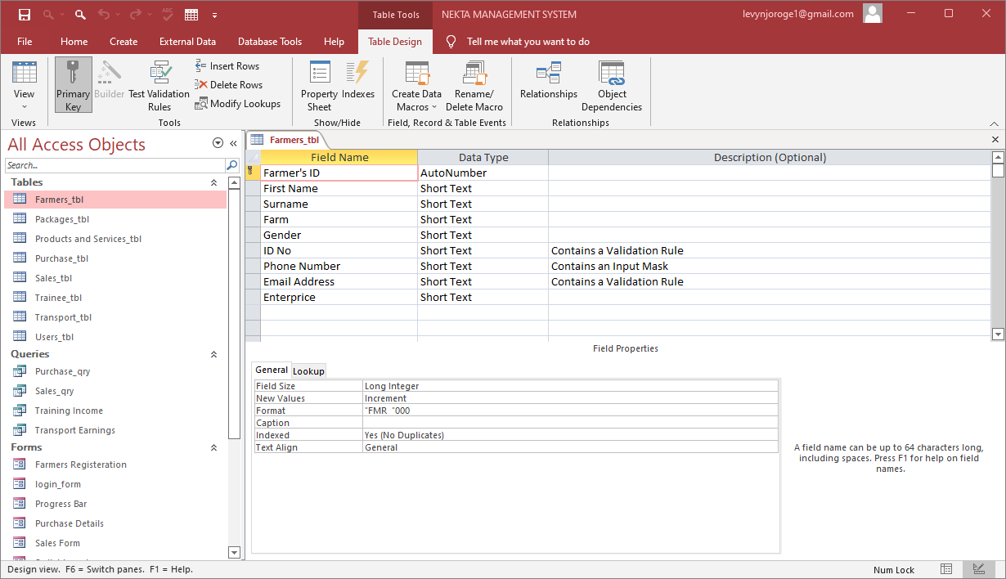

Figure 3.1: Farmers Table

### Package Table

The table in design view in Figure is used to keep record of Packages that a customer can buy.

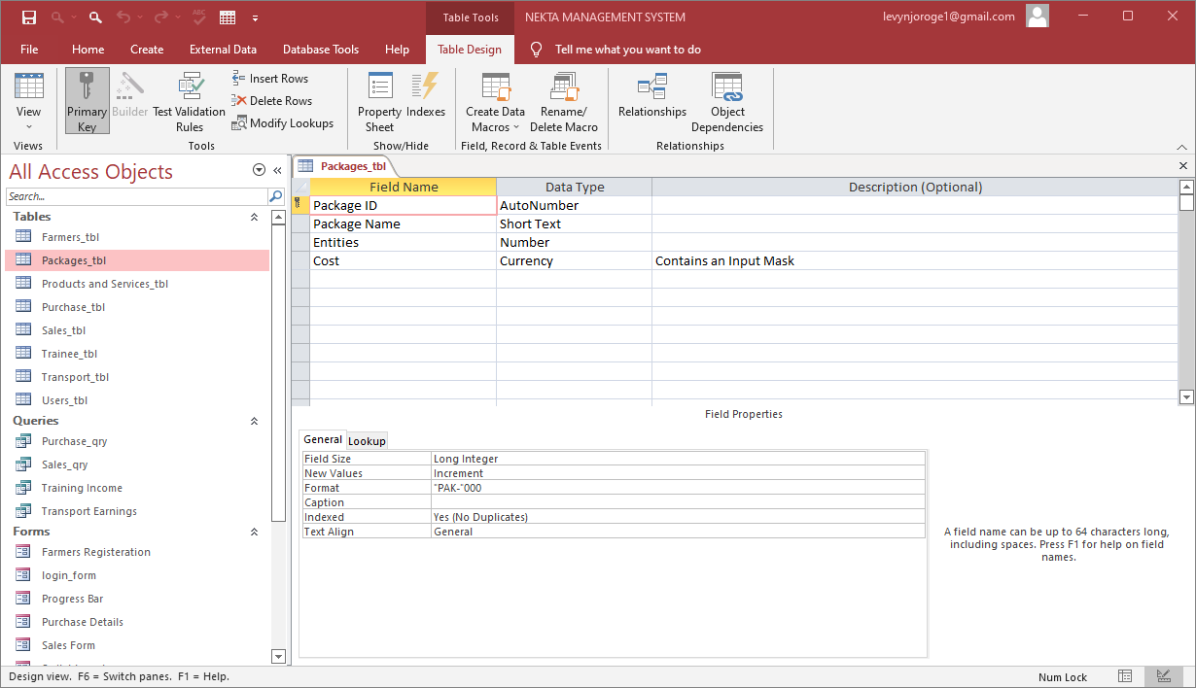

Figure 3.2: Package Table

### Products and Services Table

The table shown in design view in *Figure 3.3* is used to record the products and services offered by the company.

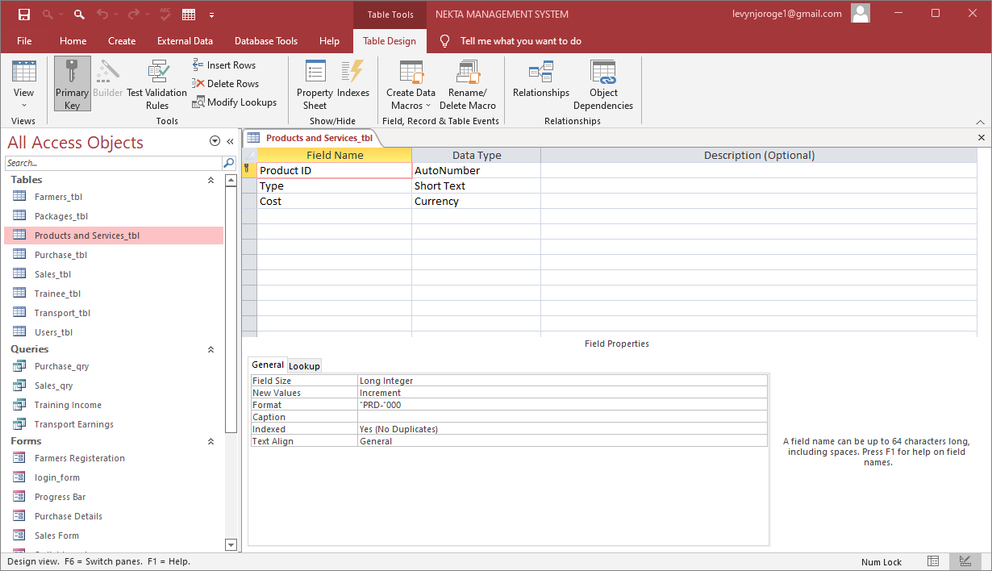

Figure 3.3: Products and Services Table

### Purchase Table

The Purchase table shown in design view in *Figure 3.4* is used in storing the records of the sales of the farmers to the Nekta Company.

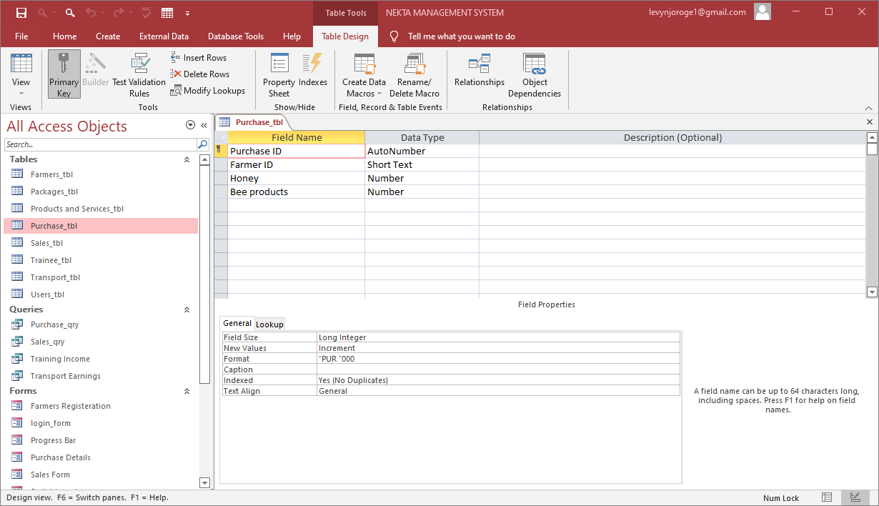

Figure 3.4: Purchase Table

### Sales Table

The Sales table shown in design view in *Figure 3.5* keeps records of the sales made by the Nekta Company to its clients.

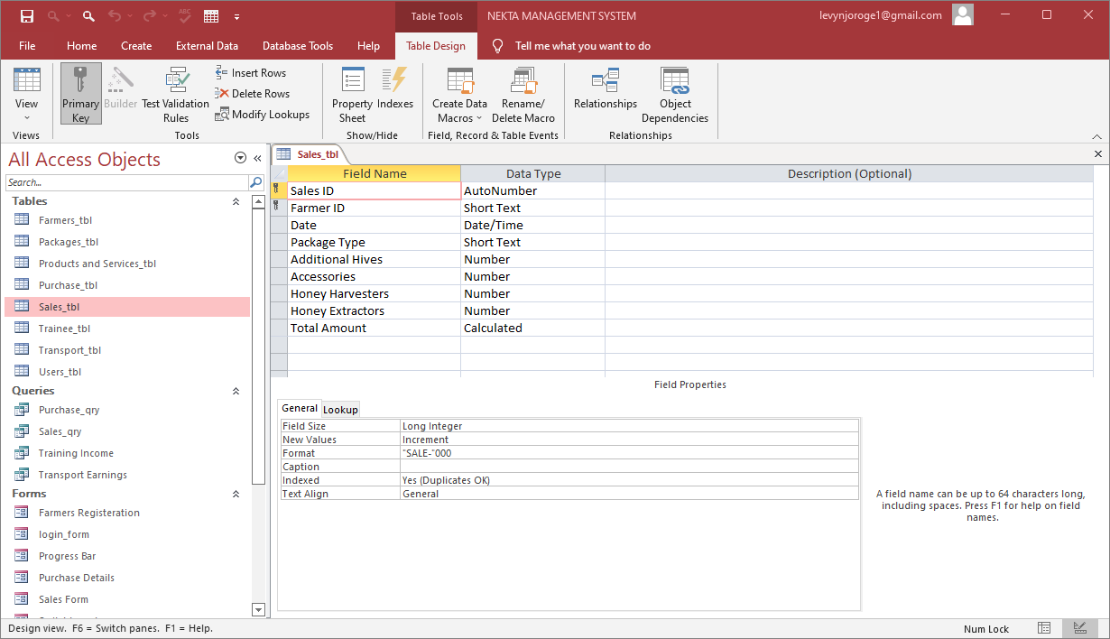

Figure 3.5: Sales Table

### Trainee Table

The Trainee table shown in design view in Figure 3.6 is used to keep records of the persons registered under the Nekta Company training programme.

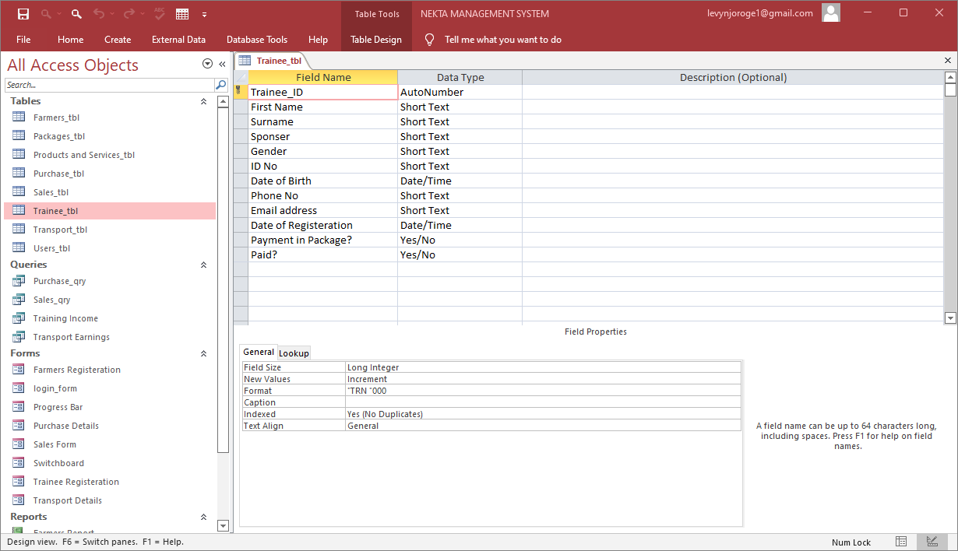

Figure 3.6: Trainee Table

### Transport Table

The Transport table shown in design view in *Figure 3.7* is used to store the records of transport activities requested by the client.

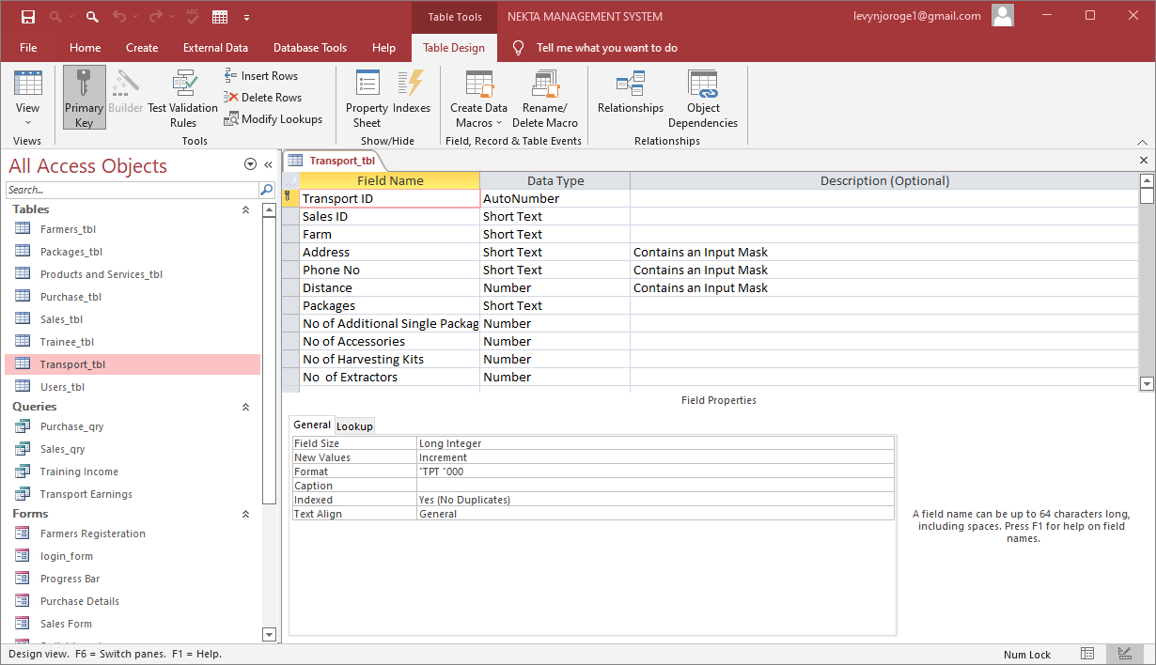

Figure 3.7: Transport Table

## Database relationship diagram

The database relationship shown in the Figure was created to help in the creation of queries and looking up some data in different tables.

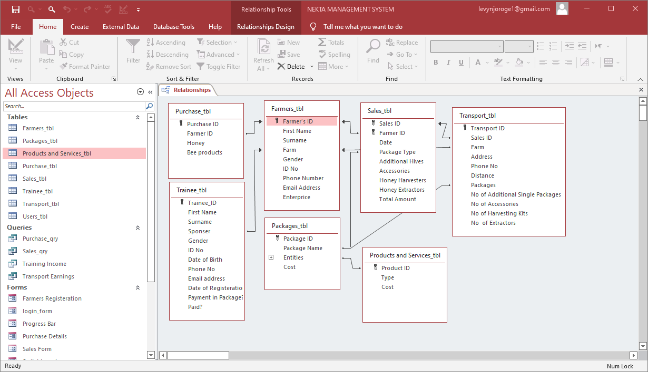

Figure 3.8: Tables Relationship

## Database Input Forms

The following are the form used to enter data into the Nekta Management System.

### Farmer’s Registration Form

This form is used to enter details required for farmers to be registered into the company.

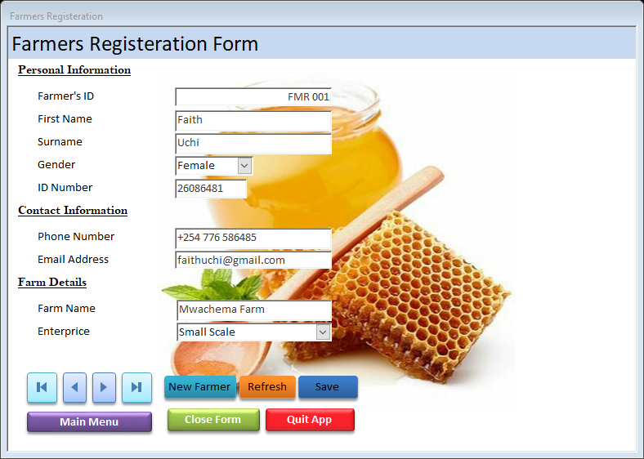

Figure 3.9: Farmer’s Registration Form

### Sales/Orders Form

The form in *Figure 3.10* is used to capture customers’ orders for the products offered by the company. The marquee running at the top is used to give the customer information about the products offered by the company. The form also displays the Totals Amount.

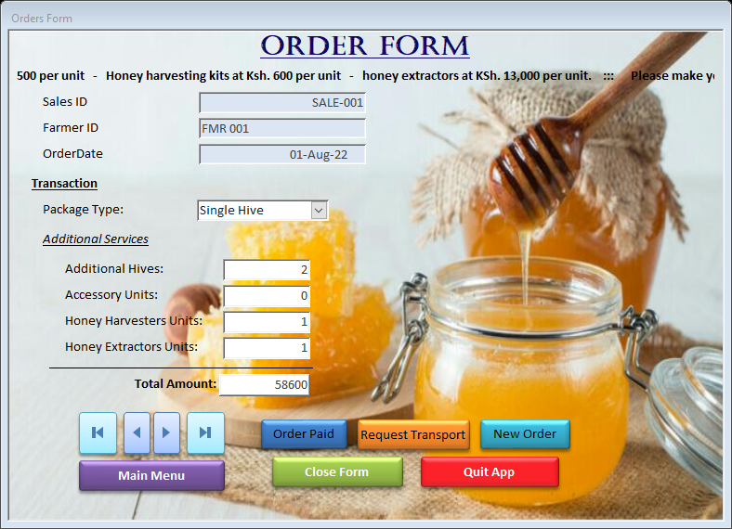

Figure 3.10: Sales Form

1. Purchase Form

The form below in *Figure 3.11* is used to capture sales made by the farmer to the company. It also displays the total amount of sales and the payment method. It contains a marquee giving information about the prices at which the company buys products from the farmer.

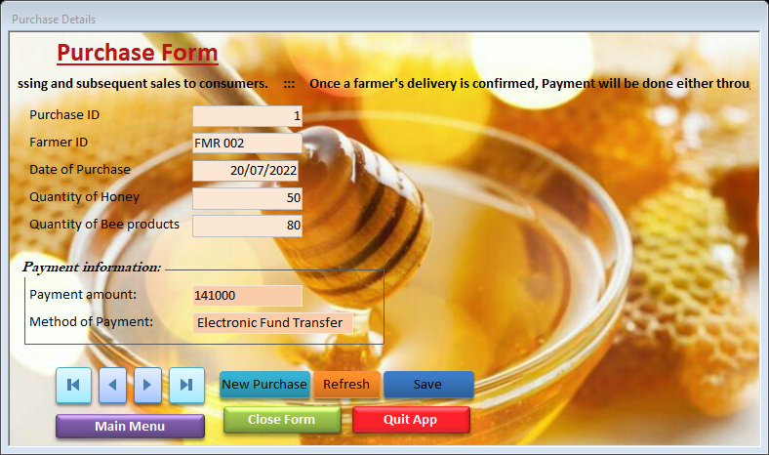

Figure 3.11: Purchase Form

### Transport Form

The form in *Figure 3.12* is used by customers who require their goods transported to enter the details of their transport.

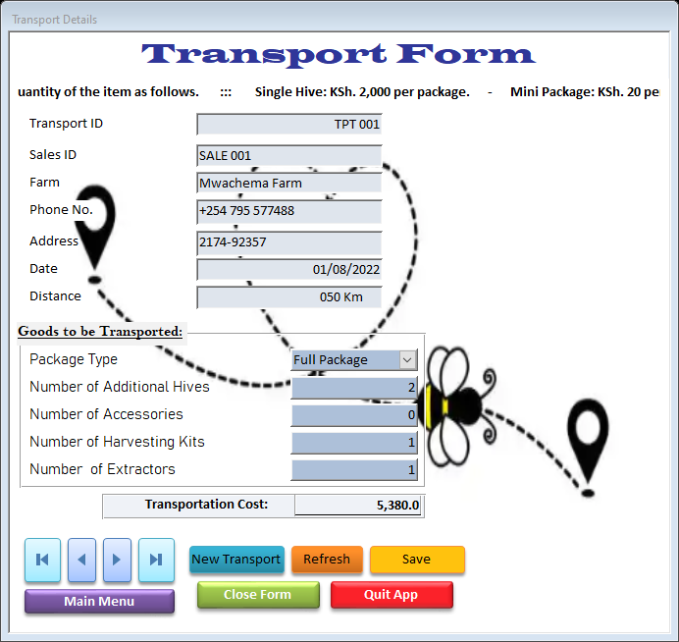

Figure 3.12: Transport Form

### Trainee Registration Form

The Trainee Registration Form shown in *Figure 2.13* is used to fill the details of the trainee for registration. The marquee at the top displays the cost of training and trainee requirements.

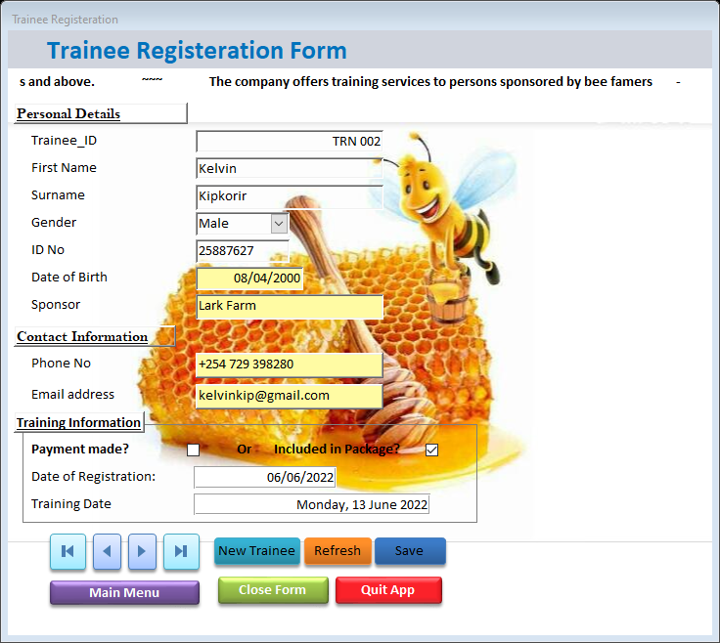

Figure 3.13: Trainee Registration Form

### Main Switchboard

The switchboard shown in *Figure 3.14* is the main menu that is loaded when NektaMS application is launched. The form consists of menus from which t0 choose the task to be performed.

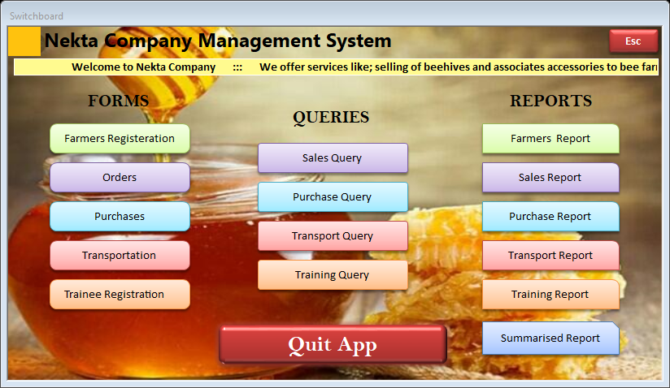

Figure 3.14: Main Switchboard

Each menu option on the switchboard has associated Macro that is executed once the user selects the option. *Figure 3.15* shows the macro associated with Farmers Registration menu option.

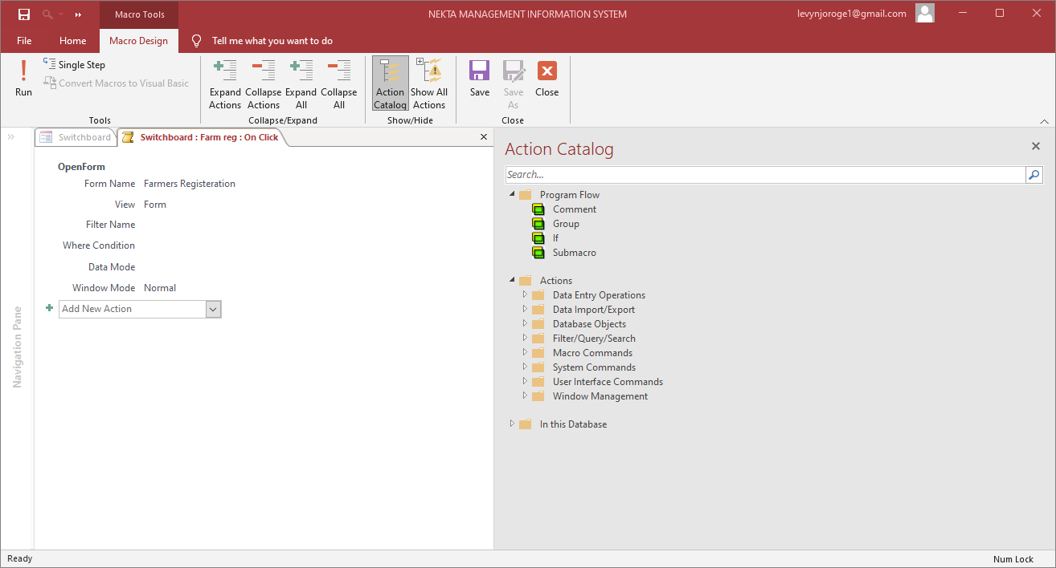

Figure 3.15: Macro for opening Farmers Registration Form

## Database Queries

In order to generate reports, we need to combine several tables and create queries to be used to process various transactions.

### Sales Query

The Sales Query shown in design view in the *Figure 3.16* below is used to process the sales cost for each product. It draws data from the Sales_tbl. The last field is a calculated field that computes Total Sales Amount.

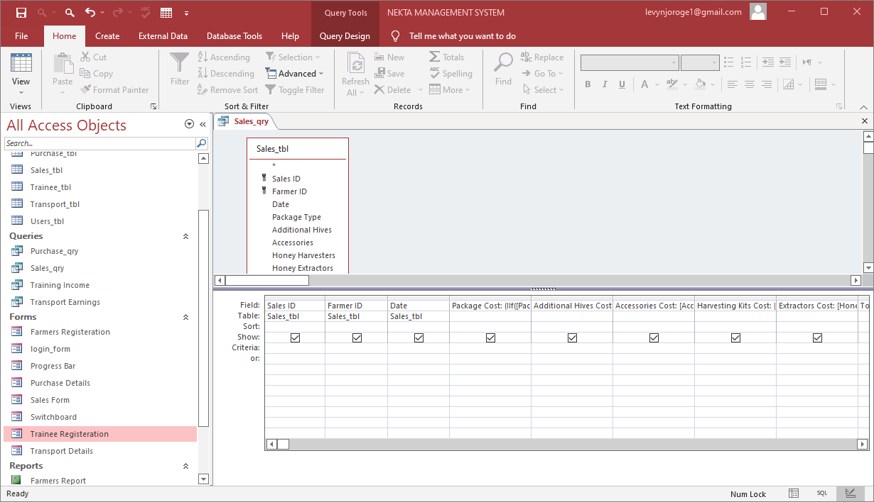

Figure 3.16: Sales Query

### Purchase Query

The Purchase query shown in design view in Figure 3.17 is used to process the cost of the products that the farmers sell to the Company and also the method of payment.

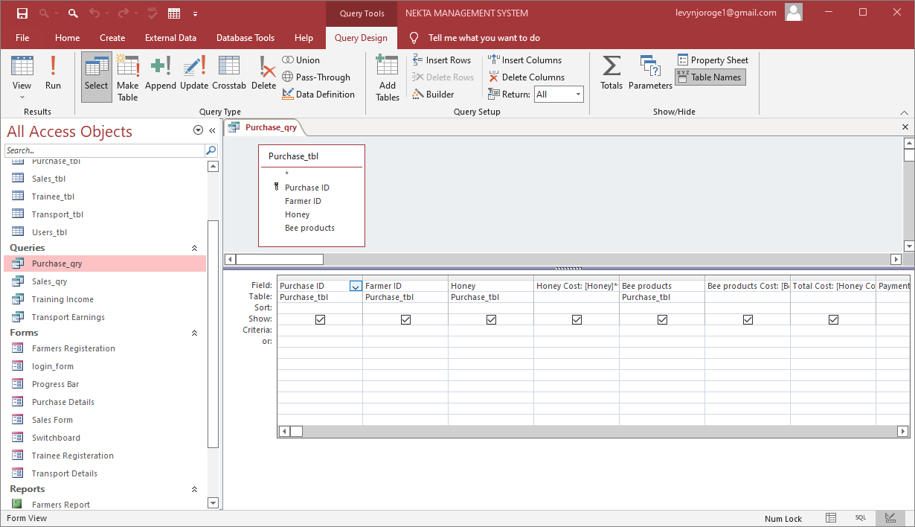

Figure 3.17: Purchase Query

### Transport Query

The Transport Query shown in design view in *Figure 3.18* is used to process the cost of transportation of the different locations desired by the farmers.

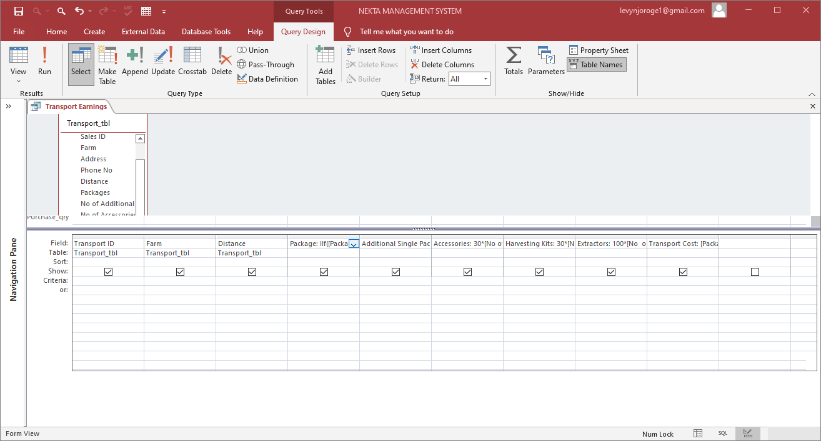

Figure 3.18: Transport Query

### Training Income Query

This Training Income Query shown in the Figure 1.19 is used to generate the training cost and date. The last field calculates the training cost from the following expression: Training Cost= IIf([Paid?] =True,7000,0)

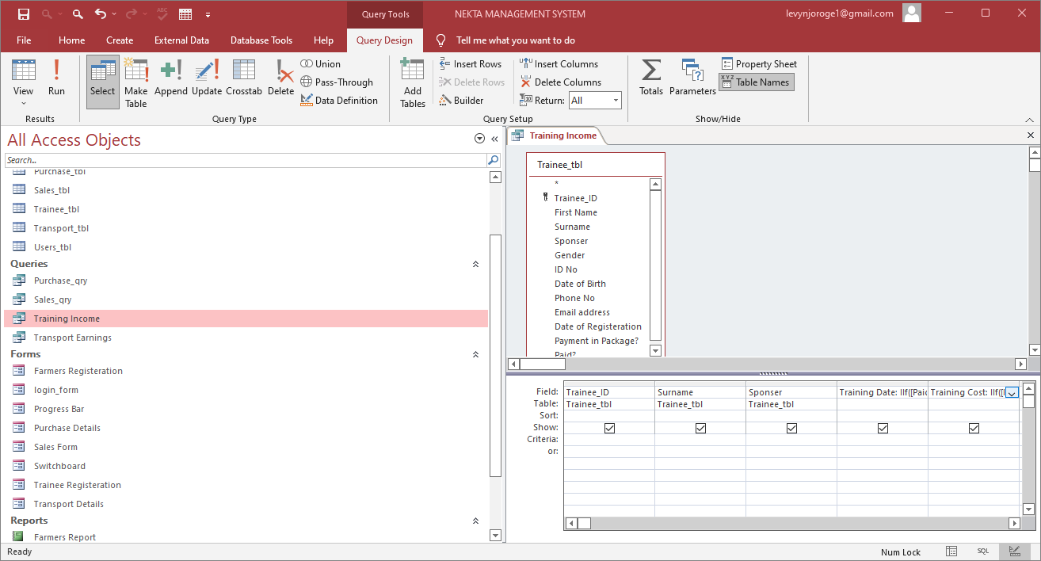

Figure 3.19: Trainee Income Query

Apart from queries, other data manipulation methods used in the development of the system include functions such as the one shown below used to calculate the total company income:

=DSum ("[Total Sales Amount]","Sales_qry”) +DSum ("[Training Cost]","Training Income”) +DSum ("[Transport Cost]","Transport Earnings")

To calculate the net company profit, a percentage of 18.5% of the income was assumed as tax and subtracted from the income.

## Generating Reports

There are several reports generated from the NektaMS which are used in presentation of necessary information. These includes:

### Farmers Report

The report shown in *Figure 3.20* keeps the records of all the farmers registered to the company. It draws its data from the Farmers_tbl.

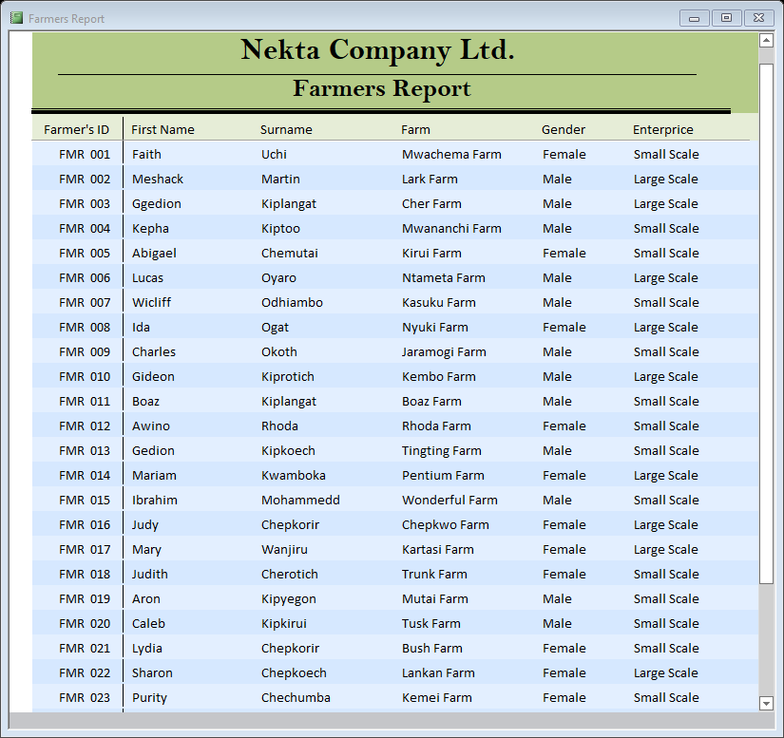

Figure 3.20: Farmers Report

### Sales Report

The Sales Report shown in *Figure 3.21* is a summary report for the company’s sales. It draws its data form the Sales_qry and Sales_tbl.

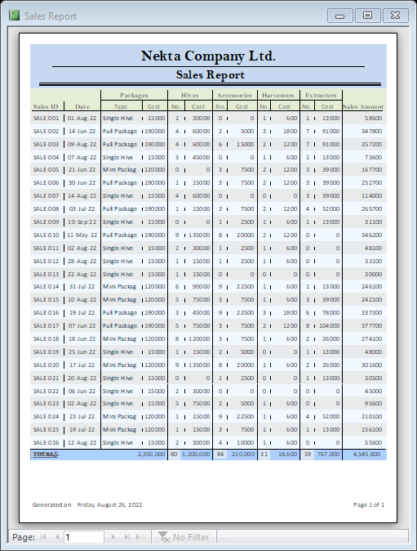

Figure 3.21: Sales Report

### Purchase Report

The Purchase Report shown in *Figure 3.22* gives a summarised report on the Purchases that the company has made from the farmers. The data in the report has been drawn from the Purchase_qry and the Purchase_tbl.

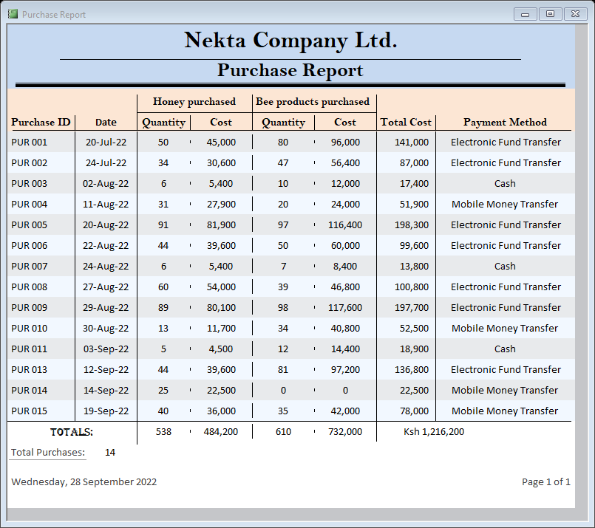

Figure 3.22: Purchase Report

### Transport Reports

The Report shown in *Figure 3.23* gives a summarised report on the income the company has made through transport services. The data in the report has been drawn from the Transport_qry and the Transport_tbl.

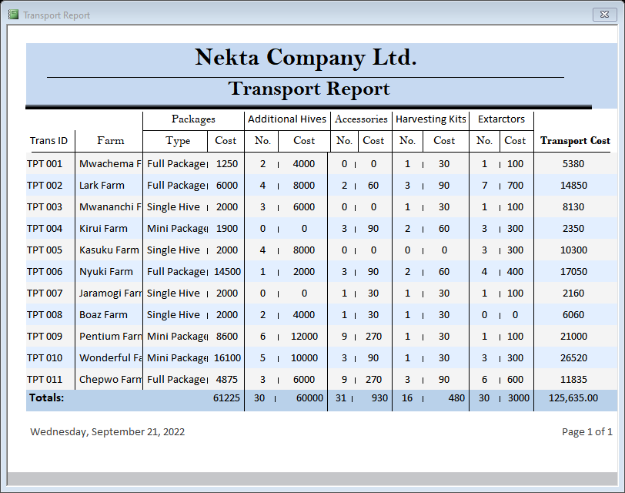

Figure 3.23: Transport Report

### Training Report

The *Figure 3.24* shown below is used to display the company earnings from the training services it offers. Data in this report is obtained from the Training_tbl and Training_qry.

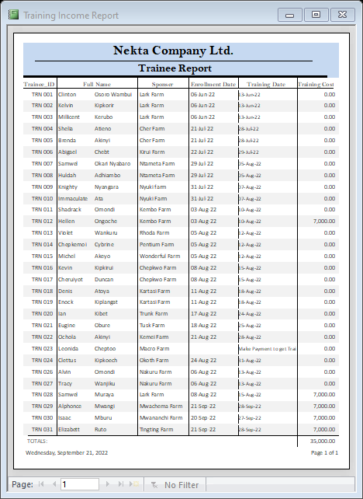

Figure 3.24: Trainee Report

### Summarised Report

This is a report summarising the company statistics. As shown in the *Figure 3.25*, it draws its data from all the queries and also the Farmers_tbl and Trainee_tbl.

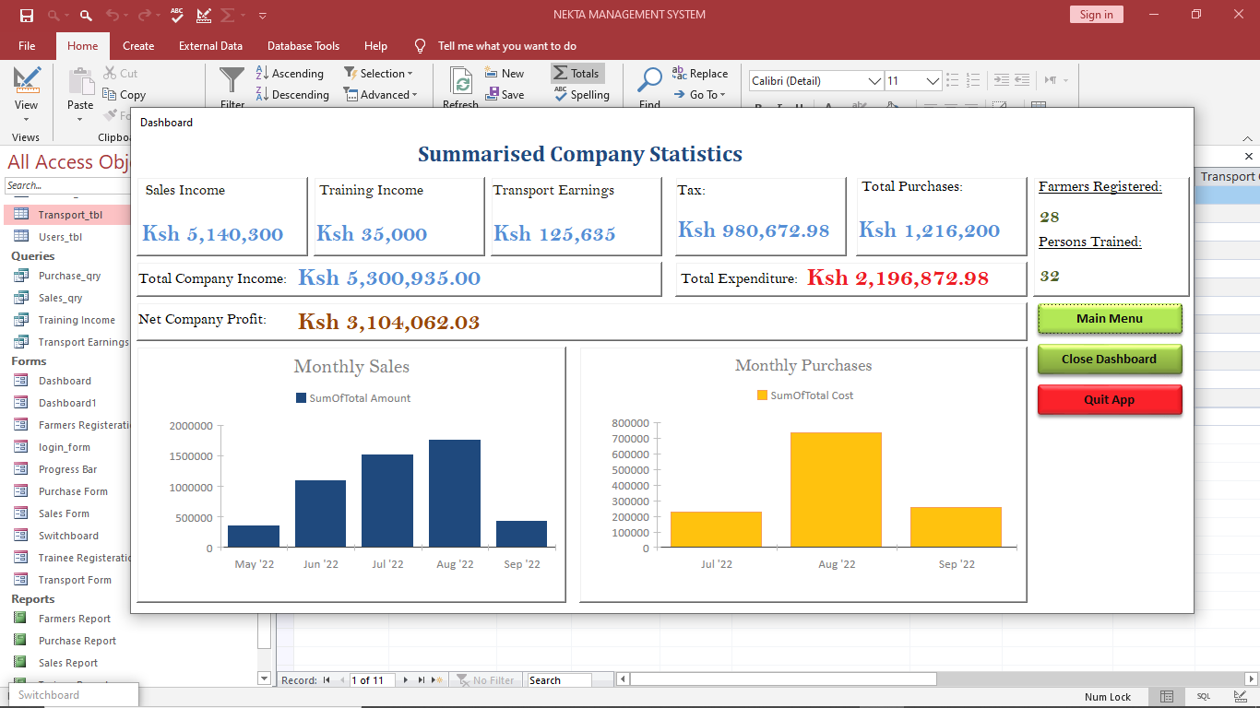

Figure 3.25: Summarised Report

## Enforcing System Security

To provide a defence against unauthorised access to the company’s database, the system development team saw it necessary to use passwords for encryption purposes.

Passwords were preferred to other data encryption methods because it is the simplest security set-up whose magnitude of protection relies on the strength of the password.

To access the main switchboard, the user types the correct password to open the system.

# SYSTEM IMPLEMENTATION

After testing each system module and correcting the errors, the system was now ready for implementation. This final stage was carried out by the development team.

The team was also responsible for installation and configuration of the NektaMS. This was done after a week of refresher training of the company’s responsible staff on how to use the new system.

The system is now projected to run smoothly and efficiently, as required by the Nekta Company.

# USER MANUAL

## Installation Guide

Requirements needed for the installation of the NektaMS are categorised into two:

1. Hardware requirement
2. Software requirement

The table below gives a summary of the hardware and software required for this system.

|  |  |  |  |
| --- | --- | --- | --- |
| **Item** | **Specification** | **Cost** | **Account** |
| * 1. Hardware | 1 Central Server | 350,000 | 350,000 |
| 5 Workstations | 80,000 | 400,000 |
| 1 Laser printers | 42,000 | 42,000 |
| 2 Thermal Printers | 24,000 | 48,000 |
| 1 Windows Server OS | 300,000 | 300,000 |
| 5 Windows Workstation OS | 15,000 | 75,000 |
| * 1. Software | 5 Microsoft Office | 15,000 | 75,000 |
| 5 Antivirus Software | 3,000 | 15,000 |
| **TOTALS:** | | | 1,305,000 |

Note: For the software requirements;

The Ms Office required is of version 2016 or later.

The Windows Operating System preferred is Windows 10 or later, for efficient running of the system.

## Loading the system

To load the system, proceed as follows:

1. Click the Start Menu, on the All Apps list, select NektaMS.
2. The system will start and run. A splash screen is displayed as shown in *Figure 5.1* below:

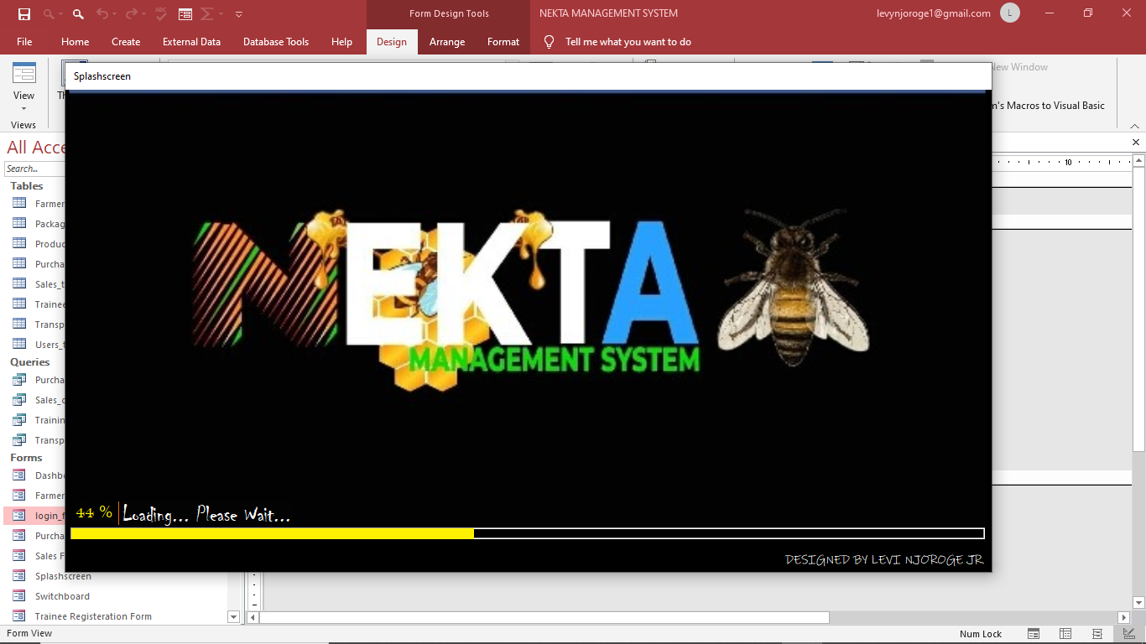

Figure 5.1: Splash screen

1. After the loading is complete, the login form is displayed as shown in the *Figure 5.2* below:

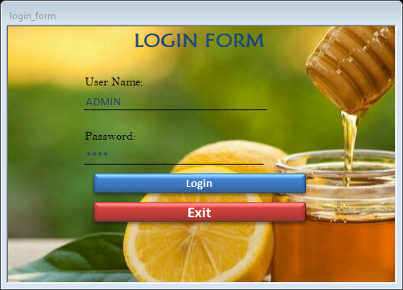

Figure 5.2: Login Form

1. Enter the correct username and password then click Login.
2. The log in details then get authenticated then the NektaMS Switchboard appears.

## Data entry procedure

On the main menu/switchboard, the user can select an option from one of the three menu groups:

1. Forms
2. Queries
3. Reports

For data entry, the user selects a form from the Forms group shown in the *Figure 5.3* below:

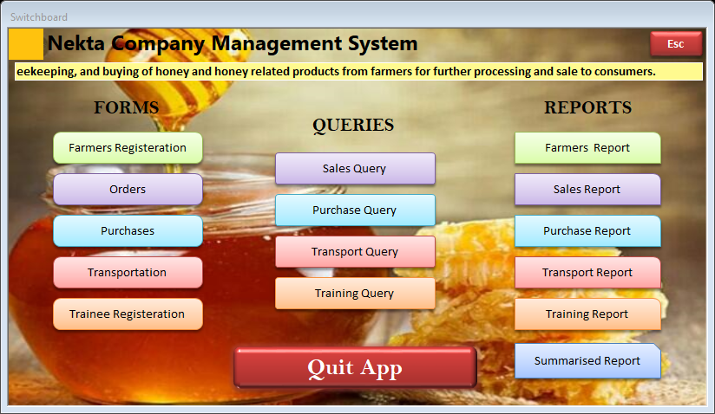

Figure 5.3: Forms Menu group

The options here include:

1. Farmer Registration – Select this option to enter the farmer’s details for registration.
2. Orders – Select this option to enter the customer’s order.
3. Purchases – Select this option to enter the details of the goods that the farmer is selling to the company.
4. Transportation – Select this option to enter details about the transport needs of the client
5. Trainee Registration – Select this to enter the trainee’s details required.

## Navigation Guide

For Forms, for the user to navigate easily, navigation buttons as shown in the *Figure 5.4* and *Figure 5.5* below are used:

Select to open a blank record to register a new farmer.

Press to refresh form

Select to save record

Press to close the NektaMS app

Press to open the switchboard

Press to close the form

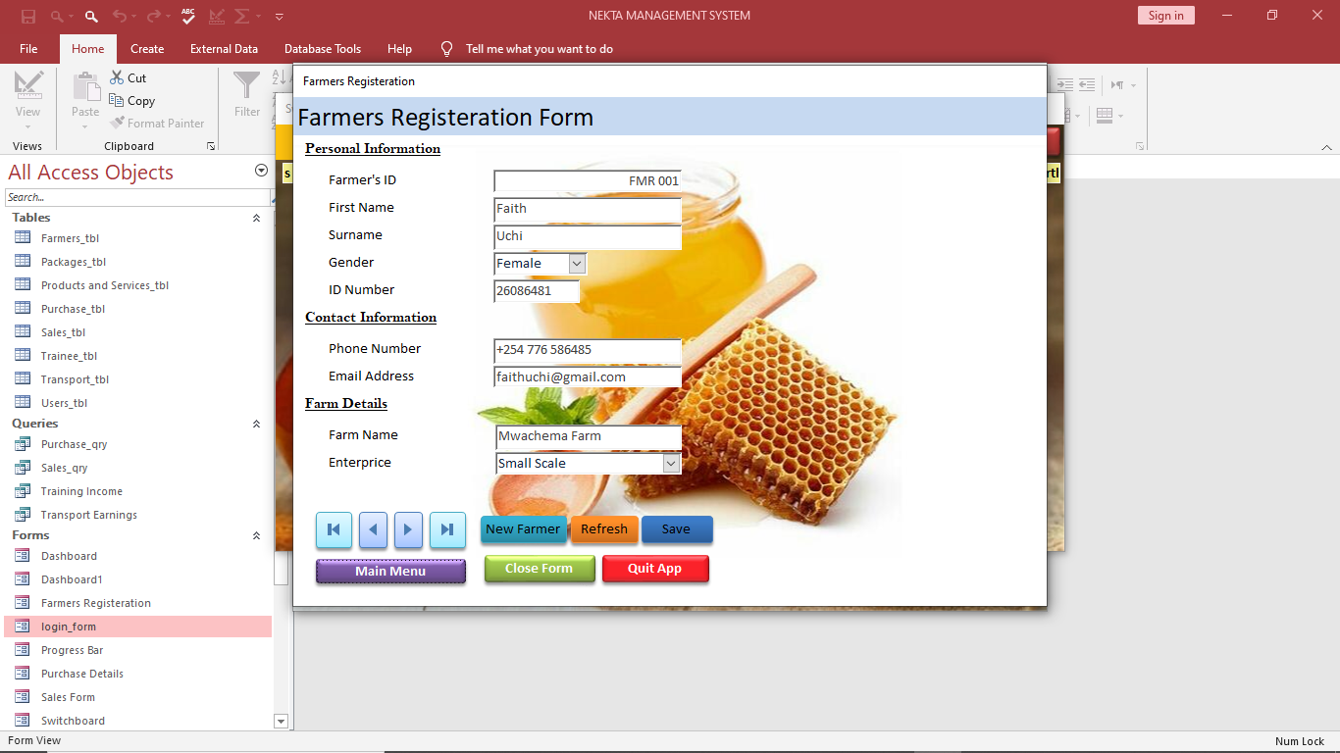

Figure 5.4: Navigation Guide 1

Move to first record

Move to previous record

Move to next record

Move to last record

Press to Confirm payment of an order

Press if the customer requires transportation for his/her good. This opens the Transport form

Press to open a blank record to make new order

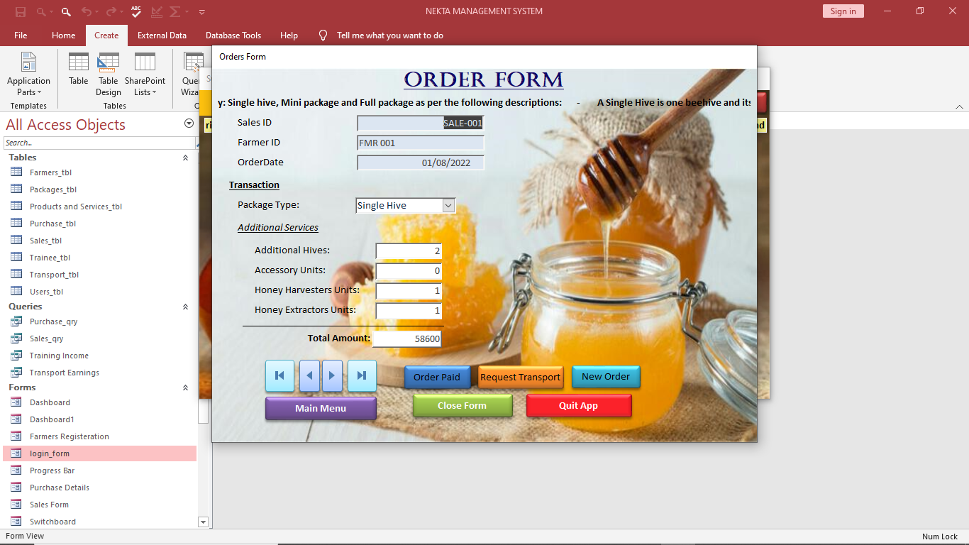

Figure 5.5: Navigation Guide 2

With the switchboard, to minimise its window, click once the Esc button at the top right part of the form:

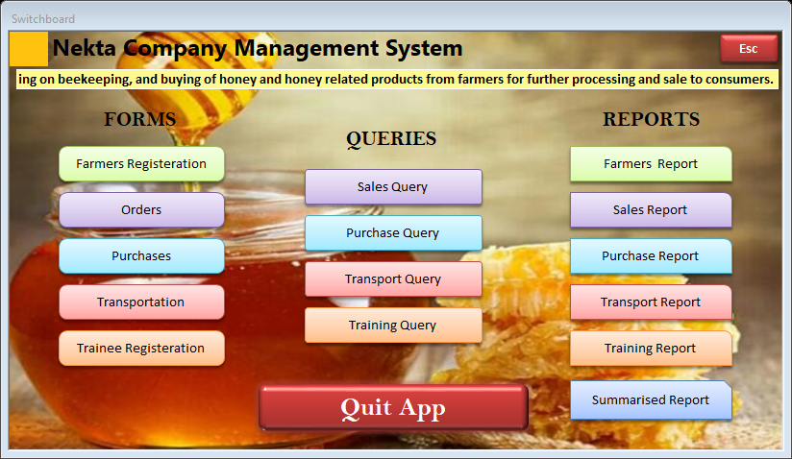

Figure 5.6: Navigation Guide 3

To open a minimised switchboard, double click the switchboard button at the bottom left of the screen just above the Start button:

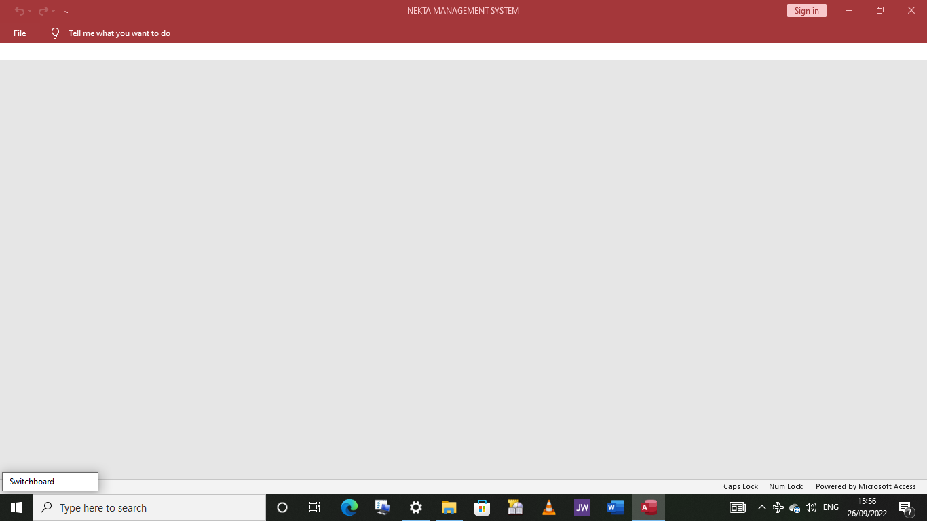

Figure 5.7: Navigation Guide 4

This is useful when viewing queries and tables since they do not pop up.

## Output Generation

On the right-hand side of the switchboard, the user can choose an option from the Reports group to generate a specific report. The Reports group is show in the Figure below:

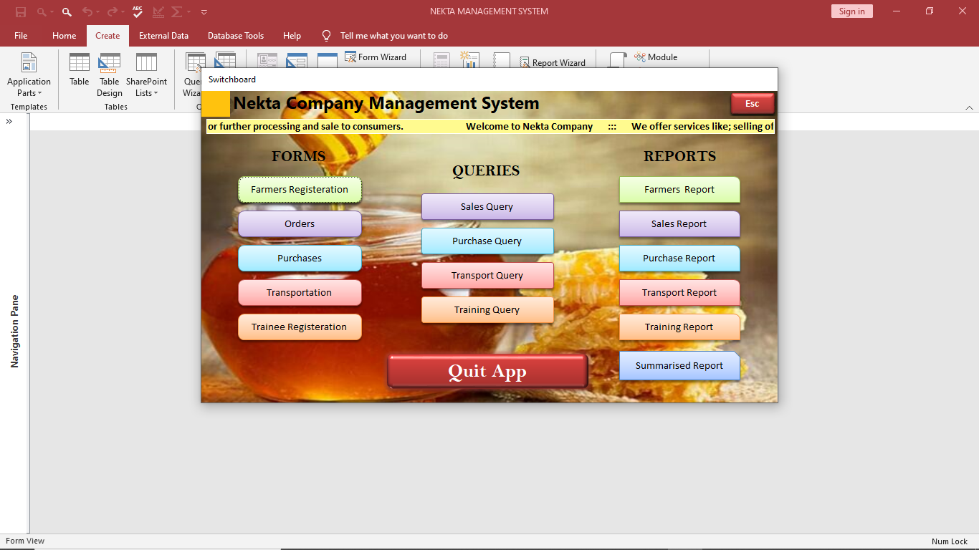  
The options include:

Figure 5.8: Reports Menu Group

1. Farmers Report – This option is used to generate a report on registered farmers.
2. Sales Report – This option generates a report on the sales made to clients.
3. Purchase Report – Select this option to generate a report on the sales made by the farmers to the company.
4. Transport Report – Generate a report on the income the company has made through transport services.
5. Training Report – Use to generate a report on the trainees registered.
6. Summarised Report – This menu is used to generate the company’s dashboard, which is a report summarising the company statistics.

## Closing NektaMS

To exit the program, simply click the Quit App button located at the bottom of any form, the switchboard and also the dashboard.

## Troubleshooting guide

Invalid and erroneous data entry results to error messages being prompted on the screen. Some of the error messages that the user may encounter are:

1. Error message: “Please enter the full ID Number with 8 numeral digits”.

Description: You are trying to proceed to another field or record yet you haven’t entered the full digits of the ID Number as required by the field.

Solution: The user is required to complete entering the ID Number digits.

1. Error message: “Please enter the email address with an '@' sign and the full domain name (for example, 'access@example.com')”.

Description: You are attempting to proceed to the next field or record yet you haven’t entered the email address as required by the field.

Solution: Enter the email address with the username then the @ symbol followed by the domain name, a dot then finally the domain.

1. Error message: “Invalid username!” Or “Invalid password!”.

Description: You are trying to access the system with an incorrect username or password.

Solution: Enter the correct login information. If you do not know the correct username or password, consult the system administrator.

# CONCLUSION

In order to remain competitive in business, the Nekta Company is required to take advantage of benefits realised from use of ICT. This is why the new Nekta Company management came up with this brilliant idea of computerising crucial business operations and processes. This goal has been met by developing an automated management system known as the NektaMS.

# RECOMMENDATION

The current business operations and processes of the Nekta company are unfriendly, inefficient and uneconomical. The development team therefore recommends that the company adopts automated NektaMS total quality management using not only a desktop management system but also using mobile devices. This will make the company get closer to its clients.

# BIBLIOGRAPHY

The bibliography below shows a list of books and references materials used in developing NektaMS.

1. Dr. John omega: introduction to microcomputers and programming, information system
2. Mburu S. & Chemwa G (2018): Longhorn Secondary Computer Studies Form 1, Longhorn Publishers, Nairobi.
3. Mburu S. & Chemwa G (2018): Longhorn Secondary Computer Studies Form 2, Longhorn Publishers, Nairobi.
4. Mburu S. & Chemwa G (2018): Longhorn Secondary Computer Studies Form 3, Longhorn Publishers, Nairobi.
5. Mburu S. & Chemwa G (2018): Longhorn Secondary Computer Studies Form 4, Longhorn Publishers, Nairobi.
6. Salem N.A: system theory and management information system simplified, N.A Salem, 1997&2000